Crop Recommendation Using Ensemble Techniques

¹B. Ammanni, Asst. Prof , ²U. Apoorva, Student
¹Depart. CSE-AI & ML, MLR Institute of Technology, Dundigal, bammanni@mlrit.ac.in
²Depart. CSE-AI & ML, MLR Institute of Technology, Dundigal, 23r21a6654@mlrit.ac.in

ABSTRACT

In this paper, a machine-learning framework based on ensemble methods is proposed to make reliable crop recommendations. Declining yields and unpredictable weather are twin challenges. The system combines several base learners and enhances prediction accuracy using bagging, boosting, and stacking. To suggest the best crop for the given set of conditions, the model was trained on agricultural data on nitrogen, phosphorus, and potassium levels, soil pH, temperature, humidity, and rainfall. Boosting was the most robust and generalizable model of those tested, reaching an accuracy of 92.58%. This trained model was then deployed as a web application using Flask to provide a real-time user interface for crop prediction. During testing, the deployed application generated predictions consistent with the underlying dataset.

Keywords:
Precision agriculture, ensemble learning, crop recommendation, boosting, Flask deployment, machine learning

- INTRODUCTION
Agriculture in India is shaped by wide variation in soil quality, unpredictable climate patterns, and limited access to analytical tools, all of which make crop selection difficult for farmers. This study describes a crop recommendation system based on the use of different base models which are then refined through ensemble learning. The dataset comes from real agricultural fields in the Kadapa district of Andhra Pradesh and includes soil data with respect to the levels of N, P, K, and pH, in addition to the local weather data of that region with respect to temperature, humidity, and rainfall.Three traditional algorithms Linear Regression (LR), Support Vector Machine (SVM), and Random Forest (RF) were assessed along three ensemble methods (Bagging, Boosting, and Stacking), and of the results obtained through the experiment, the best and most generalizable results were produced with the stacking method, with XGBoost as the meta-learner. The system was built in Flask and a web application was created to interface the ML system with the decision support system farmers use.

- LITERATURE REVIEW

Several works address ways to enhance the performance of crop recommendation systems by means of improving model accuracy and its scalability. In [1], authors suggest a recommendation system that uses ensemble learning such as Random Forest, Decision Tree, and Gradient Boosting to increase productivity. Although, this method was more efficient compared to using single learners, it performed poorly under various climatic conditions. Similar works can be found in [2], where authors compare performance of machine learning algorithms such as SVM, K-Nearest Neighbor, and Naive Bayes for agricultural predictions. These approaches were more efficient in terms of classification but poorly adapted to heterogeneous data sets requiring much pre-processing work. Back in [3], authors have tried to combine filter and wrapper techniques for feature selection that basically meant that the data set was being reduced, the process became more eddicient and the model obtained higher accuracy. Further on, in [4], authors have applied the genetic algorithm for feature selection, which helped to considerably increase the accuracy of the yield predictions whether regression or neural network is used. The bottom line is that if you use proper information about the soil and climate, the accuracy of your predictions will definitely increase. In [6], authors have tested various machine learning algorithms on their performance in predicting crop productivity. Ensemble method showed the highest performance in terms of managing heterogeneity and various regions. Over in [7], someone has used a deep neural network to predict how soil nutrient content and environmental factors interact. The model showed perfect results in terms of accuracy but the data requirements were tremendous as well as the training time. Definitely not the most efficient method if you need your results fast. Things become more interesting in [8], hybrid ensemble methods, such as boosting with neural etworks have proven themselves as a good trade-off between accuracy and speed. In [10], machine learning and remote sensing data combination showed itself as a promising approach. But adaptation of models in different regions is still an open question. It is quite difficult task. Recently, there has been much activity in the field of stacking-based ensembles in precision agriculture. In [11], multi-level ensembles that included Bagging, Boosting, and Stacking showed high accuracy and adaptability to local datasets. Also, [12] describes the Crop Cast Study where the XGBoost was used as a meta-learner in stacking technique which resulted in highly accurate yield predictions.

III. PROPOSED METHODOLOGY

The proposed framework uses ensemble techniques to predict the best crop for a particular soil-climatic conditions. Mixing up the base models might produce a more accurate and robust model in the face of different field conditions. Pipeline has four phases- data preprocessing, training, performance evaluation, and deployment.

3.1 Data Collection and Description

The data set has been prepared from the actual soil and environment conditions in a selected agricultural fields of Kadapa district, Andhra Pradesh, India and the soil and environmental parameters most closely associated with crop growth for this area have been included, such as nitrogen (N), phosphorous (P), potassium (K), pH, temperature, humidity and rainfall.

3.2 Data Preprocessing

The raw data is being preprocessed to be used in the model. The data is preprocessed by removing nulls, feature scaling and label encoding.
- Data Cleaning: Checked and eliminated null and inconsistent data.
- Normalization: Applied min-max scaling to keep the features balanced.
- Feature Selection: Selected the most relevant parameters influencing crop productivity.
- Label Encoding: Transformed target crop names into numeric labels for model training.

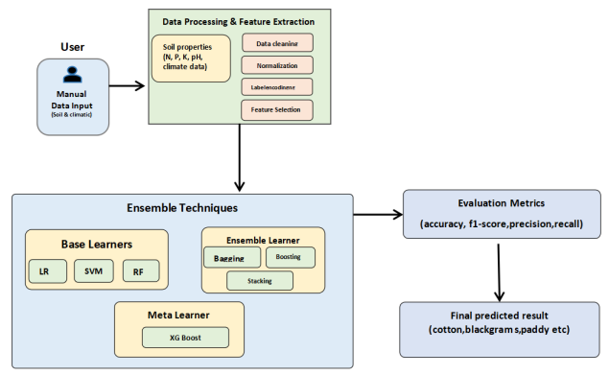

Fig. 1. Architecture of Crop Recommendation System Using Ensemble Techniques.
The proposed system architecture, as illustrated in Fig.1, consists of four main components: user input, data preprocessing and feature extraction, ensemble-based model development, and performance evaluation. The architecture highlights the integration of base learners (LR, SVM, RF) and ensemble models (Bagging, Boosting, Stacking) with XGBoost as the meta-learner to generate the final crop prediction.

3.3 Model Development

The system is divided into two main parts:
- Existing Models (Base Learners)
- Proposed Ensemble Models (Enhanced Learners)

1. Existing Models
To establish a baseline, three classical ML algorithms were used:
- Linear Regression (LR): Provides a linear mapping between input variables and output crop labels.
- Support Vector Machine (SVM): This model uses the idea of hyperplanes to classify the crops by means of obtaining the most suitable hyperplane dividing crops according to soil and climatic characteristics.
- Random Forest (RF): Application of this model consists of constructing various decision trees to be applied to many problems to solve the task of non-linearity and robustness.
All the models used under analysis are benchmarked models that offer a comparison of their performance.

2.Proposed Ensemble Models
Each model has its own limitations, so we used some ensemble techniques to improve the results:
- Bagging (Bootstrap Aggregation): Trains several base models on different random subsamples of the data and averages their predictions. It reduces variance.
$$\hat{y}=\frac{1}{n} \sum_{i=1}^{n}{h_{i}\left(x\right)}$$

- Boosting: It lines up weak learners one after another, each time focusing more on the mistakes from the previous round. This way, it keeps shrinking the bias.
$$F_{m \left(x\right)}= F_{\left\{m−1\right\}\left(x\right)}+ α_{m}h_{m\left(x\right)}$$

- Stacking: In the case of stacking, predictions from the former two are fed into an XGBoost meta-learner to pick up on more intricate patterns.
$$\hat{y}= H\left(h_{1\left(x\right)}, h_{2\left(x\right)}, …, h_{n\left(x\right)}\right)$$
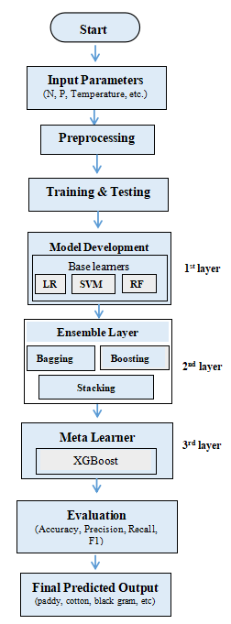

Fig. 2. Workflow of the proposed Crop Recommendation System

3.4 Model Evaluation
We tested the crop recommendation system with some traditional models such as linear regression, SVM and random forest and some heavy weight ensemble models: bagging, boosting and stacking. We did not have numbers in our dataset for the sake of numbers. All of the important elements are included: soil nutrients (N, P, K), pH, rainfall, temperature, humidity, soil type.
To assess the performance of each model, we routinely tested accuracy, precision, recall, and F1-score, all on a distinct dataset, the ensemble methods were the clear winners. Stacking with XGBoost in particular was the most accurate and proved its mettle under varying conditions. The result is a dependable model capable of making spot-on recommendations even as field conditions shift.
3.5 Model Deployment and Integration
To make sure our crop recommendation system wasn’t just good on paper, we built a prototype web app using Flask. Using plugins their soil and environmental data, the app fires back the best crop suggestion, powered by our trained model. We started out simple. First, we fed the system a small mock dataset, just to check that everything worked-data in, prediction out, no hiccups. For real-world use, the model trains on the full, real dataset, using those same ensemble methods (bagging, boosting, stacking) and XGBoost at the core to keep the predictions sharp.
Once trained, we deployed the ensemble model through the Flask web interface for instant predictions. For example, when we entered N=50, P=14, K=270, Temperature=34.5, Humidity=77.4, pH=8.0, Rainfall=834.3, and EC=0.1, the system came back with Cotton. That lined up perfectly with the real dataset, so we knew the deployment and integration worked.
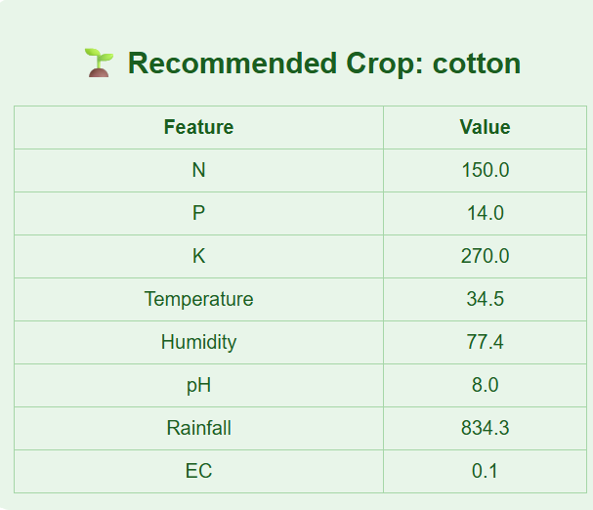
Fig. 3. Web interface of the deployed crop recommendation system.
This prototype covers the whole journey from user input to crop prediction and shows the system is ready for action on real data. The model fits the right data into the app, offering real-time predictions, checking user inputs, and showing results clearly. All of this makes it genuinely useful for precision agriculture.
IV. System Performance Analysis
We checked how well the crop recommendation system worked, focusing on both how accurate the model was and how quickly the system responded once we hooked it up to the Flask web framework. To really test it, we used actual soil and weather data from Kadapa district in Andhra Pradesh, with lots of different agro-ecological conditions thrown into the mix.
A. Model Performance Evaluation
The ensemble models did a much better job than the usual machine learning algorithms. Boosting landed an accuracy of 92.58%, edging out Bagging at 91.79%, Stacking at 80.07%, and older models like Linear Regression (59.81%), SVM (89.90%), and Random Forest (93.01%). This shows the ensemble learning setup really handles tricky, nonlinear data well. Out of all the ensemble methods, boosting scored the highest accuracy, but stacking was a steady performer across the board.
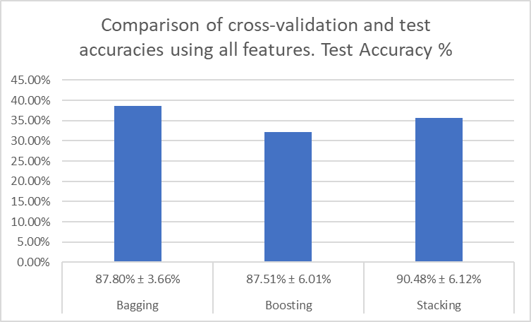
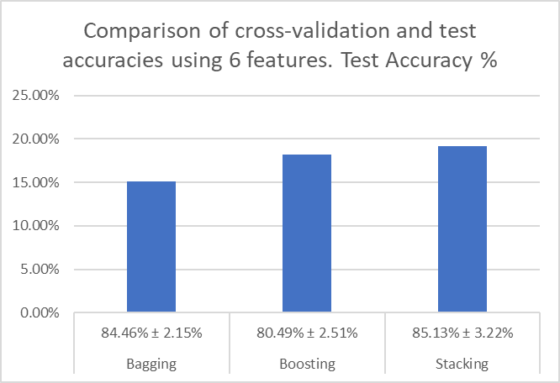
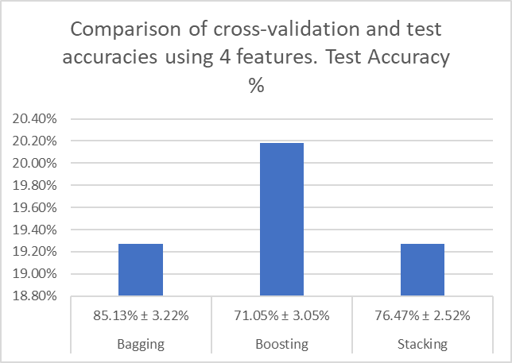
Fig. 4. Comparison of Cross-Validation and Test Accuracies for Ensemble Models using Different Feature Sets.
We measured the ensemble models using both cross-validation and test accuracy. If you look at Fig. 4, you will see stacking actually came out on top for cross-validation accuracy at 90.48%, followed closely by bagging and boosting.
B. Response Time and Efficiency
The Flask web app responds in about 1.8 seconds on average, so users get results almost instantly. Its lightweight backend keeps things fast without sacrificing the accuracy seen in offline tests.
C. Usability and System Reliability
The system interface is simple-farmers and agricultural planners can just plug in soil and environmental details. As soon as they hit submit, the model suggests the best crop for those conditions. The system gives steady, accurate predictions and is easy to use, making it a solid tool for real-world decisions in precision agriculture.
D. Comparative Analysis
When you stack this ensemble system against standalone models, it stands out. Model averaging brings more stable predictions. Boosting cuts down on errors by learning from past mistakes. And stacking, with XGBoost as the meta-learner, helps the system generalize better.
All in all, putting ensemble learning into an interactive system really boosts agricultural productivity and makes decision-making smarter.
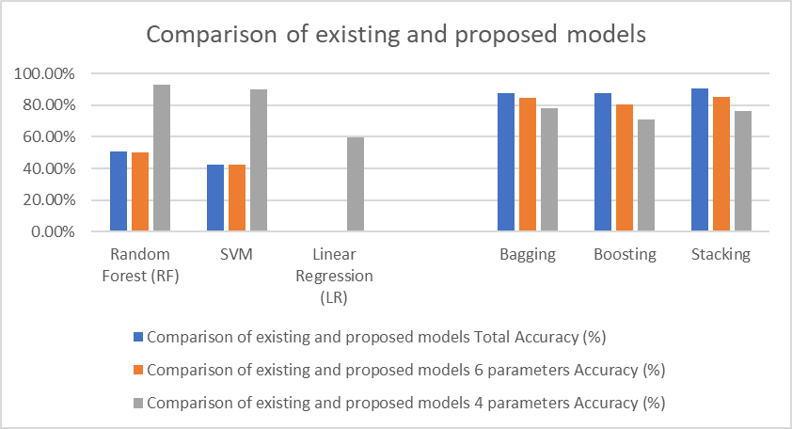
Fig. 5 Comparison of existing and proposed models for different parameter accuracies.
Fig. 5 Comparison between existing models (RF, SVM, LR) and proposed ensemble models (bagging, boosting, stacking). The ensemble methods performed better with higher accuracy. Stacking gave the best total accuracy of 90.48%.
V. Conclusion and Future Scope
This ensemble-based crop recommendation system actually nails crop predictions by pulling together both soil and climate data. Stacking, with XGBoost as the meta-learner, really pushed accuracy past what older models managed. The team set it up on the web with Flask, so you get real-time results, and those predictions lined up with the actual data. All in all, it’s a system you can count on for making smarter choices in agriculture.

Future Enhancements
This study will be expanded upon in future work by including real-time soil data from satellites and the internet of things (IoT) for dynamic updates.
- Developing a mobile application to improve accessibility for rural users.
- To further improve prediction performance, use hybrid ensemble methods or deep learning.
- Combining market and economic factors to recommend more resilient and profitable crops.
All things considered, the suggested model offers a useful, scalable, and intelligent decision-support system that can greatly benefit contemporary precision agriculture.
VI. REFERENCES
[1] N.H. Kulkarni, G.N. Srinivasan, “Improving Crop Productivity Through a Crop Recommendation System Using Ensembling Technique,” in Proc. 3rd IEEE Int. Conf. on Computational Systems and Information Technology for Sustainable Solutions (CSITSS), India, 2-18, pp. 1-6
[2]. K. G. Liakos, P. Busato, D. Moshou, and S. Pearson, “Machine Learning in Agriculture: A Review”, Sensors, vol. 18, no. 8, p. 2674, Aug. 2018, doi: 10.3390/s18082674.
[3] M.J. Madhuri and Dr. M. Indiramma, “Hybrid Filter and Wrapper Methods Based Feature Selection for Crop Recommendation”, in Proc. 2022 Int. Conf. on Electronic Systems and Intelligent Computing (ICESIC), IEEE, 2022, pp. 1-6, doi: 10.1109/ICESIC55212.2022.00023.
[4] T. A. Shaikh, W. A. Mir, T. Rasool, and S. Sofi, “Machine Learning for Smart Agriculture and Precision Farming: Towards Making the Fields Talk”, Archives of Computational Methods in Engineering, vol.29, pp. 4557-4597, Jul.2022. doi: 10.1007/s/11831-022-09761-4.
[5] B. Dey, J. Ferdous, and R. Ahmed, “Machine Learning-Based Recommendation of Agricultural and Horticultural Crop Farming in India under the Regime of NPK, Soil pH and Three Climatic Variables”, Heliyon, vol. 10, p. e25112, Jan.2024. doi: 10.1016/j.heliyon.2024.e25112.
[6] G. Anandhi and M. Lyapparaja, “Systematic Approaches to Machine Learning Models for Predicting Pesticide Toxicity”, Heliyon, vol. 10, p. e28752, Mar.2024. doi: 10.1016/j.heliyon.2024.e28752.
[7] P. Jyothika, K. V. Ramana, and C. L. Narayana, “Crop Recommendation System to Minimize Crop Yield Using Deep Neural Network”, Journal of Engineering Sciences, vol. 12, no. 11, pp. 119-123, Nov. 2021. ISSN: 0377-9254.
[8] A. Waldia, P. Garg, P. Garg, R. Tewani, A. K. Dubey, and A. Agarwal, “Crop Recommendation Using Machine Learning”, Frontiers in Plant Agriculture, vol. 6, no. 2, pp. 1-8, Aug. 2021. Doi: 10.54216/FPA.060203.
[9] R. H. L. lpa, L. -M. Ang, K. P. Seng, J. C. Broster, and J. E. Pratley, “Big Data and Machine Learning for Crop Protection”, Computers and Electronics in Agriculture, vol. 151, pp. 376-383, 2018. Doi: 10.1016/j.compag.2018.06.008.
[10] H. Liu, Y. Zhan, J. Sun, Q. Mao, and T. Wu, “A Transformer-Based Model with Feature Compensation and Local Information Enhancement for End-to-End Pest Detection”, Computer and Electronics in Agriculture, vol. 231, p. 109920, Jan. 2025. Doi: 10.1016/j.compag.2025.109920.
[11] D. B. Johnston, K. G. Pembleton, N. I. Huth, and R. C. Deo, “Comparison of Machine Learning Methods Emulating Process-Driven Crop Models”, Environmental Modelling & Software, vol. 163, pp. 105-119, Jan. 2023. doi: 10.1016/j.envsoft.2023.105119.
[12] C. Raju, D. V. Ashoka, and A. B. Prakash, “CropCast: Harvesting the Future with Interfused Machine Learning and Advanced Stacking Ensemble for Precise Crop Prediction”, Kuwait Journal of Science, vol. 51, p. 100160, Dec. 2023. Doi: 10.1016/j.kjs.2023.100160.
[13] L. Breiman, “Random forests”, Machine Learning, vol.45, pp. 5-32, 2001. Doi: 10.1023/A:1010933404324.
[14] S. Shasthri, S. Sharma, and S. Gupta, “Advancing crop recommendation system with supervised machine learning”, Scientific Reports, vol. 15, no. 1, 2025. Doi: 10.1038/s41598-025-07003-8.
[15] L. Breiman, “Bagging predictors,” Machine Learning, vol. 24, no. 2, pp. 123-140, 1996, Doi: 10.1007/BF00058655.
[16] G. Ke et al., “LightGBM: A highly efficient gradient boosting decision tree,” in Proc. Adv. Neural Inf. Process. Syst. (NeurIPS),2017, pp. 3146-3154.
[17] Scikit-learn Developers, “Preprocessing Data-scaling and normalization”. Accessed: Oct. 25, 2025. [Online]. Available: https://scikit-learn.org/stable/modules/preprocessing.html
[18] C. Cortes and V. Vapnik, “Support-vector networks”, Machine Learning, vol. 20, no. 3, pp. 273-297, 1995. Doi: 10.1007/BF00994018.
[19] D. H. Wolpert, “Stacked generalization”, Neural Networks, vol. 5, no. 2, pp. 241-259, 1992. Doi: 10.1016/S0893-6080(05)80023-1.
[20] M. Sokolova and G. Lapalme, “A systematic analysis of performance measures for classification tasks”, Information Processing & Management, vol 45, no. 4, pp.427-437, 2009. Doi: 10.1016/j.ipm.2009.03.002.
[21] N. C. Brady and R. R. Weil, “The Nature and Properties of Soils”, 15th ed. Upper Saddle River, NJ, USA: Pearson, 2016.
[22] P. Mohan Rao, K. Nageswar Rao, “Optimizing Crop Recommendation Systems Using Advanced Deep Learning Techniques”, Journal of Theoretical and Applied Information Technology, vol. 102, no. 23, pp. --, Dec. 2024.

